# Using Google Analytics to Track Your SEO Performance

Digital marketers and website owners know how key **SEO tracking** is today. **Google Analytics** is a powerful tool that turns website traffic data into useful insights. It helps professionals understand their site's performance and how users interact with it.

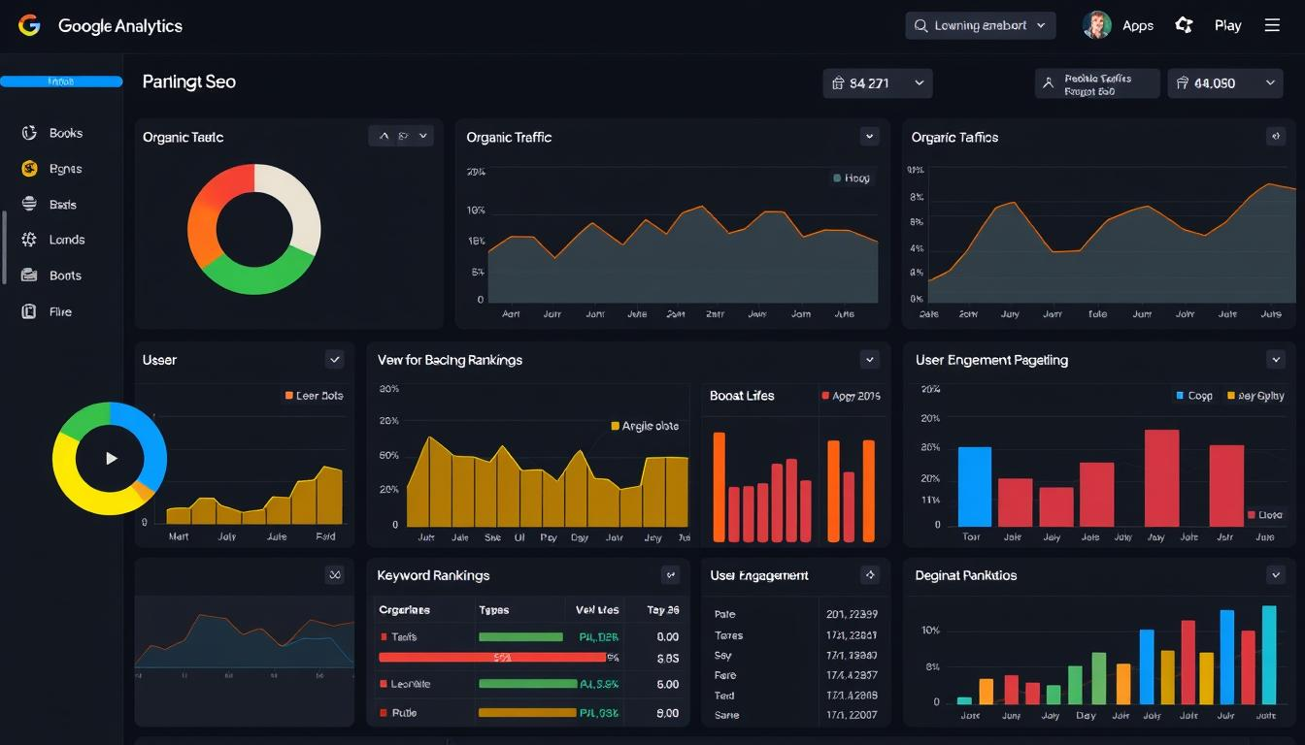**SEO analysis** needs to be precise and based on detailed data. **Google Analytics** gives businesses a lot of information. It helps them improve their online presence, understand user behavior, and boost search rankings.

Web professionals can explore complex data to find new growth opportunities. By looking at visitor patterns, bounce rates, and conversion paths, they can make better digital strategy choices.

### Key Takeaways

* **Google Analytics** offers comprehensive **SEO tracking** capabilities
* Real-time **website traffic analysis** helps identify performance trends
* **User behavior insights** drive strategic content improvements
* Detailed metrics support data-driven marketing decisions
* Free platform provides advanced tracking for businesses of all sizes

## Understanding Google Analytics for SEO Performance Tracking

Digital marketers and SEO experts use powerful tools to track website performance. Google Analytics is key for understanding and improving SEO. It offers deep insights into how to boost **organic search rankings**.

Understanding **website optimization** is complex. Google Analytics helps by providing a strong framework for tracking and improving digital marketing efforts.

### Key Features and Benefits for SEO Professionals

* Real-time organic search traffic monitoring
* Detailed user behavior analysis
* Comprehensive website performance tracking
* Customizable reporting and insights

### Getting Started with Google Analytics 4

Google Analytics 4 brings advanced tracking features. It uses machine learning to offer deeper insights into user behavior and search patterns. This helps businesses understand their audience better.

| Feature | SEO Benefit |
| --- | --- |
| Cross-Platform Tracking | Unified view of user engagement |
| Machine Learning Insights | Predictive audience behavior |
| Event-Based Tracking | Detailed interaction analysis |

### Basic Setup Requirements

1. Create a Google Analytics account
2. Install tracking code on your website
3. Configure data streams
4. Set up conversion goals

"Data is the new oil. Analytics is the combustion engine." - Peter Sondergaard

By following these steps, SEO experts can gain powerful insights. This helps with continuous **website optimization** and better **organic search rankings**.

## Setting Up Your Google Analytics Dashboard for SEO Monitoring

Creating a good Google Analytics dashboard is key for tracking your website's performance. It makes **SEO tracking** easier when you focus on the most important metrics for your online strategy.

https://www.youtube.com/watch?v=TqW38z7RbeY

* Navigate to the Google Analytics dashboard
* Select the *Customization* option
* Click on *Create New Dashboard*
* Choose widgets that match your SEO goals

"A well-designed dashboard transforms raw data into actionable insights." - Digital Marketing Experts

For SEO tracking, you need certain widgets:

| Widget Type | Purpose |
| --- | --- |
| Organic Traffic Overview | Track search engine visitor numbers |
| Keyword Performance | Monitor top-performing search terms |
| Page Speed Insights | Analyze website loading performance |

Keeping your dashboard up-to-date is crucial for good website monitoring. Update your widgets often to keep them relevant to your SEO goals.

## Essential SEO Metrics to Track in Google Analytics

It's key to track the right SEO metrics to see how your website is doing. Google Analytics has tools to help you see how your site is growing and how well your online plan is working.

Digital marketers should look at three main areas to get a full view of their site's performance:

### Organic Traffic Metrics

Organic traffic metrics show how people find your site through search engines. Important signs include:

* Total organic search visitors
* Organic traffic percentage
* New vs. returning organic visitors
* Search query performance

### Behavior Metrics

Knowing how users interact helps improve your site's conversion and content. Key behavior metrics are:

* Average time on page
* Bounce rate
* Pages per session
* User engagement depth

### Conversion Metrics

Conversion metrics turn visitors into real business results. Keep an eye on these key ones:

* Goal completions
* Conversion rate
* Revenue per visitor
* Funnel visualization

"Data is the new oil. Analytics is the combustion engine." - Peter Sondergaard, Gartner Research

By understanding these SEO metrics, digital marketers can make plans that boost organic traffic and enhance site performance.

## Google Analytics, SEO tracking, SEO analysis: Core Components

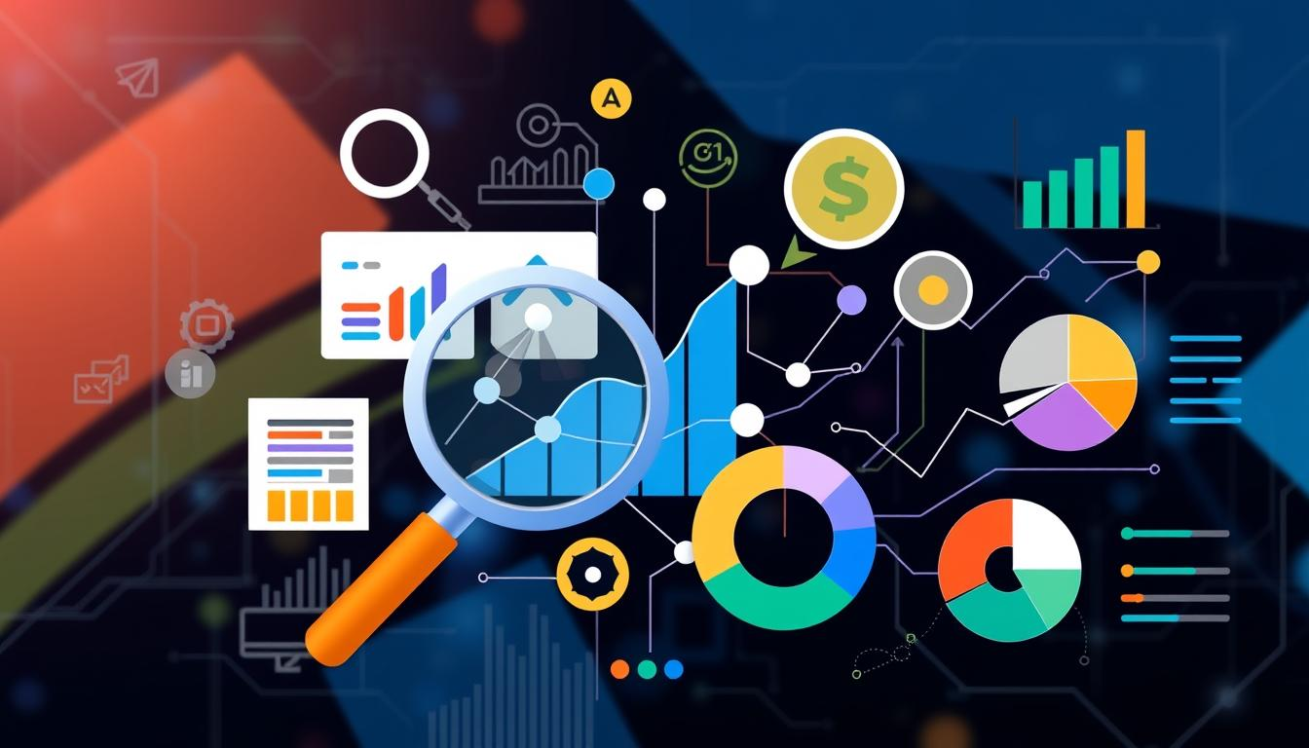Digital marketers use Google Analytics as a key tool for SEO tracking and analysis. It turns website data into useful insights. This helps in making better SEO strategies.

Google Analytics has important parts for SEO success:

* Traffic Source Analysis
* User Behavior Tracking
* Conversion Rate Monitoring
* Performance Measurement

**SEO analysis** starts with knowing how these parts work together. Marketers use these tools to:

1. Find the best content
2. Learn about their audience
3. Check how well they do in search
4. Make websites better for users

"Data is the new oil of the digital marketing landscape." - Analytics Expert

To track SEO well, you need to know how to read Google Analytics data. Experts use this knowledge to make websites more visible and better for users.

| Component | Key Functionality | SEO Impact |
| --- | --- | --- |
| Organic Traffic | Measure search engine visitors | High visibility assessment |
| User Behavior | Track page interactions | Content optimization |
| Conversion Metrics | Analyze user actions | Performance improvement |

*Strategic data interpretation turns Google Analytics into a strong SEO tool.*

## Analyzing User Behavior Patterns and Search Intent

**Digital marketing analytics** give us key insights into how users interact with websites. Knowing how users behave is vital for making SEO strategies better. This helps improve how well your site ranks in searches.

By tracking how users interact, we learn a lot about how well our sites work and how engaged our audience is. Good digital marketers use these insights to make their content better and improve the user experience.

### Understanding User Flow

User flow analysis shows us how visitors move through your website. It covers:

* Entry point tracking
* Page-to-page movement patterns
* Identifying high-performing and problematic navigation paths

### Search Query Analysis

Looking at search queries gives us deep insights into what users want and what content is relevant. Marketers can:

1. Identify most frequent search terms
2. Understand user language and expectations
3. Refine content strategy based on actual search behaviors

### Exit Page Insights

Studying exit pages helps us find where users might get stuck. By carefully looking at these pages, we can:

| Exit Page Type | Potential Improvement Strategy |
| --- | --- |
| High-traffic exit pages | Optimize content and call-to-action placement |
| Conversion-critical pages | Enhance user experience and reduce barriers |

"Understanding user behavior is the key to unlocking digital marketing success." - Digital Marketing Expert

*Leveraging user behavior insights turns raw data into chances to boost search rankings and digital marketing success.*

## Tracking Organic Search Performance and Rankings

https://www.youtube.com/watch?v=8NjBWQIaf3I

Getting better at **organic search rankings** needs a smart plan to check SEO performance. Google Analytics has great tools for digital marketers. They help understand **search ranking factors** and improve website performance.

"Data is the compass that guides successful SEO strategies." - Digital Marketing Experts

To track organic search performance well, look at important metrics. These show how visible your website is in searches:

* Organic traffic volume
* Keyword ranking positions
* Click-through rates (CTR)
* Search query performance

Looking closely at **search ranking factors** helps find out what content works best. *Google Analytics 4 gives detailed insights into user behavior and search patterns*. This lets marketers fine-tune their SEO plans.

Key steps for tracking organic search performance are:

1. Set up organic search tracking in Google Analytics
2. Create custom dashboards for fast performance checks
3. Watch keyword ranking trends
4. Look at user engagement metrics

Using these **SEO performance metrics**, marketers can make choices based on data. This improves organic search rankings and boosts website traffic.

## Measuring Content Performance and Engagement

Digital marketers know how key it is to track content success. Google Analytics offers tools to see how well your content connects with people. It also shows how it keeps users engaged.

Creating a good content strategy means looking at more than just numbers. By using data to guide your marketing, you can learn a lot about your content's real impact.

### Page Value Assessment

To figure out your content's worth, you need to look at a few important things:

* Conversion rates
* Time spent on page
* Revenue generated per content piece
* Goal completion frequency

### Content Grouping Strategies

Putting your content into groups makes it easier to analyze. This way, you can see how different types of content do. It helps you focus on what works best.

1. Create thematic content clusters
2. Analyze performance within each group
3. Identify top-performing content types

### Engagement Metrics Analysis

"Numbers tell a story - your job is to understand the narrative behind the data." - Digital Marketing Experts

Important metrics include bounce rate, scroll depth, and how users interact. These show you how people are really using your content. They help you make your content better.

## Converting Data into Actionable SEO Strategies

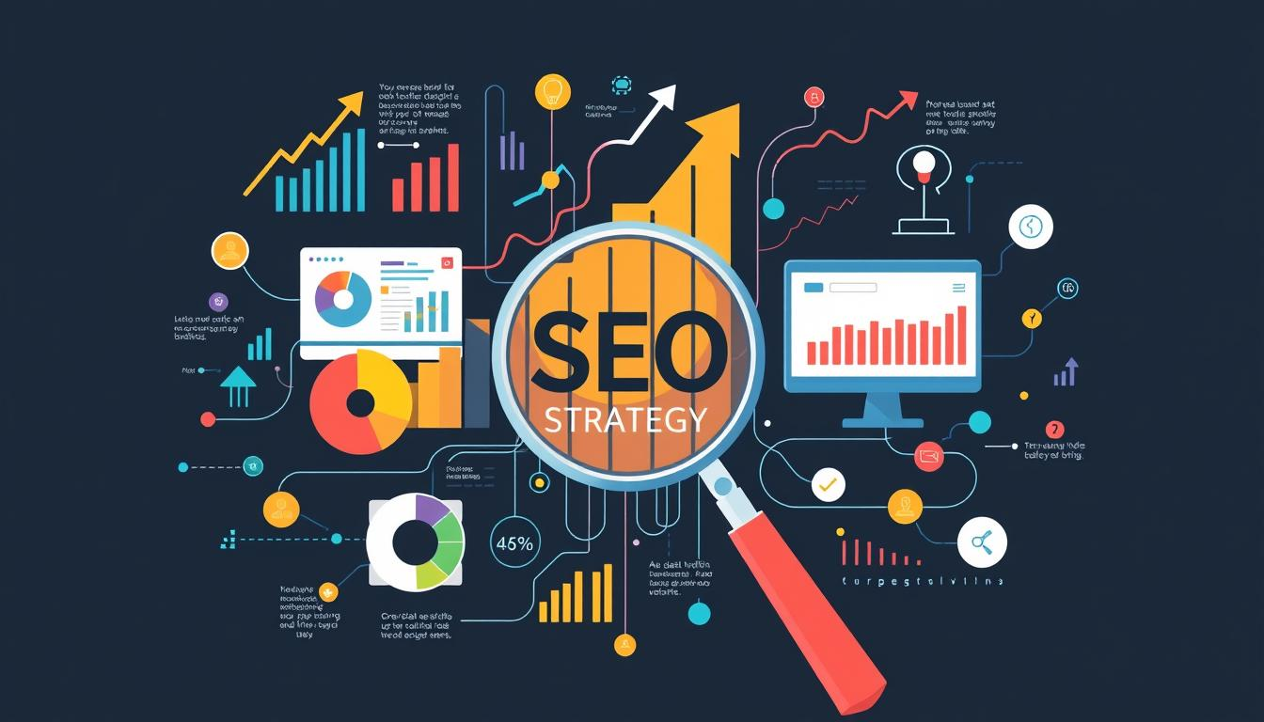Turning **digital marketing analytics** into strong SEO strategies needs a clear plan. Data-driven SEO is key for online success, helping businesses make smart digital choices.

To turn data into useful insights, focus on important metrics. These metrics affect search rankings and how users interact with your site. The steps are:

* Find top-performing content
* Study how users behave
* Spot areas for improvement
* Create specific plans for betterment

"Data is the new oil, but analytics is the combustion engine that turns raw information into strategic power." - Digital Marketing Experts

Good **website optimization** starts with knowing your analytics. Marketers use these insights to:

1. Decide which content to update
2. Refine what keywords to use
3. Make the site easier to use
4. Boost conversion rates

| Analytics Metric | Optimization Strategy | Expected Outcome |
| --- | --- | --- |
| Bounce Rate | Improve Page Load Speed | Increased User Engagement |
| Organic Search Traffic | Content Refinement | Higher Search Rankings |
| Conversion Rate | User Experience Optimization | Improved Conversion Metrics |

*Using data-driven SEO strategies means always watching and adjusting. Seeing analytics as a living tool helps marketers make better digital plans.*

## Advanced Segment Analysis for SEO Optimization

Diving deep into **audience segmentation** changes how marketers see website traffic and user behavior. Google Analytics offers tools to simplify complex data. This makes it easier to create strategies that boost SEO.

Good **audience segmentation** lets digital marketers find detailed patterns in user actions. They can then make their websites better at reaching the right people.

### Creating Custom Segments

Custom segments give detailed insights by filtering website traffic. They look at things like:

* Demographics
* Device type
* User engagement levels
* Traffic sources

### Audience Behavior Analysis

Understanding user behavior is more than just numbers. Advanced analysis uncovers:

1. Conversion path variations
2. Content interaction patterns
3. Potential user experience barriers

### Geographic Performance Tracking

Looking at location-based segments gives key insights into how different areas perform. It shows what audiences prefer.

| Region | Traffic Volume | Conversion Rate |
| --- | --- | --- |
| North America | 45% | 3.2% |
| Europe | 35% | 2.8% |
| Asia Pacific | 20% | 2.5% |

"Segmentation is not about addressing everyone the same way, but understanding unique user characteristics." - Digital Marketing Expert

Using these advanced segment analysis methods, marketers can make SEO strategies that really speak to specific groups.

## Integrating Google Analytics with Other SEO Tools

**Data-driven SEO strategies** need insights from many tools. Google Analytics is key, but adding more tools can give deeper insights.

https://www.youtube.com/watch?v=StHPWPR4nko

Smart digital marketers use many tools together. This creates a strong **SEO analysis** system. Some important integrations include:

* SEMrush for keyword research and competitive analysis
* Ahrefs for backlink tracking and domain authority insights
* Moz Pro for comprehensive website optimization recommendations
* Screaming Frog for technical SEO diagnostics

These integrations help share data smoothly. This gives a full view of your digital marketing. By linking tools, you can:

1. Find trends across platforms
2. Make reporting easier
3. Develop detailed SEO tracking plans
4. Automate complex analysis

"Integration transforms isolated data points into strategic insights." - Digital Marketing Expert

Setting up tool integrations needs careful setup and knowing each tool's API. Most SEO tools connect easily with Google Analytics. This makes it simpler to gather and analyze data.

| Tool | Primary Integration Benefit | Complexity Level |
| --- | --- | --- |
| SEMrush | Keyword Performance Tracking | Low |
| Ahrefs | Backlink Analysis | Medium |
| Moz Pro | Technical SEO Insights | High |

By linking Google Analytics with other SEO tools, marketers can make better, data-driven SEO plans. These plans can quickly adjust to digital changes.

## Generating and Customizing SEO Reports

**Digital marketing analytics** need advanced reporting tools. These tools turn raw data into useful insights. **SEO performance metrics** need smart visualization and reporting to guide marketing strategies.

Good reporting is more than just collecting data. It's about making complex digital performance easy to understand for marketers.

### Report Automation Setup

Automating SEO reports makes tracking easier and more consistent. Here's how to do it:

* Set up reports to generate automatically
* Send reports by email automatically
* Choose important performance levels
* Combine data from different sources

### Custom Dashboard Creation

Custom dashboards make digital marketing analytics easy to see. Marketers can create dashboards that focus on:

1. Key SEO metrics
2. Live traffic data
3. Conversion rate studies
4. Keyword ranking updates

### Data Visualization Techniques

Turning complex data into easy-to-understand graphics is key. Here are some strategies:

| Visualization Type | Primary Purpose | Best Use Case |
| --- | --- | --- |
| Line Graphs | Trend Tracking | Organic Traffic Changes |
| Pie Charts | Proportion Analysis | Traffic Source Breakdown |
| Heat Maps | User Interaction | Page Engagement Metrics |

"Data visualization turns complex metrics into clear strategic narratives." - Digital Marketing Expert

*Learning these reporting skills helps marketers get valuable insights from complex digital data.*

## Conclusion

Digital marketers see Google Analytics as key for tracking SEO and website performance. By using the strategies from this guide, they can gain deep insights into their online presence. This helps them understand how their audience interacts with their site.

SEO analysis gets better with Google Analytics' advanced tools. It lets businesses see how users behave and improve their content. This way, they can make choices based on data, boosting their search rankings and site performance.

Staying up-to-date is crucial in digital marketing. This guide is a solid start, but SEO needs constant improvement. Use the data to try new things and keep working to make your site better for users.

Begin using these strategies now and see your SEO improve. With Google Analytics, you're ready to handle the challenges of digital marketing and SEO.

## FAQ

### What is Google Analytics and why is it important for SEO?

Google Analytics is a tool that tracks your website's traffic and user behavior. It's key for SEO because it shows how users find and use your site. This helps you make your site better for search engines.

### How do I set up Google Analytics for my website?

First, create a Google Analytics account. Then, add a tracking code to your site. Finally, set up your property settings. It's easy: just sign up, get your tracking ID, and add the script to your site's HTML.

### What are the most important SEO metrics to track in Google Analytics?

Focus on organic traffic, bounce rate, and average session duration. Also, track conversion rate and top pages. These metrics show how users find and use your site, helping you improve SEO.

### Can Google Analytics help me understand my website's search performance?

Yes! Google Analytics shows how well your site does in search results. It tells you which keywords work best and how users interact with your site after searching.

### How often should I check my Google Analytics data?

Check it weekly, and do a deeper analysis monthly. This helps you spot trends and see how SEO changes affect your site.

### Is Google Analytics 4 different from the previous version?

Yes, Google Analytics 4 (GA4) is a big upgrade. It tracks users better, works across platforms, and uses machine learning for insights. It's more advanced than Universal Analytics.

### How can I improve my website's SEO using Google Analytics?

Use Google Analytics to find weak pages and understand user behavior. Track keywords and see what users want. Then, improve your content and site speed based on what you learn.

### What's the difference between organic and paid search traffic in Google Analytics?

Organic traffic comes from search results without ads. Paid traffic comes from ads. Google Analytics lets you see both, helping you measure their impact.

### Can Google Analytics help me track conversions?

Yes, it's great for tracking conversions. Set up goals for actions like form submissions or purchases. This shows how well your site turns visitors into customers.

### Is Google Analytics free to use?

Google Analytics has a free version for most websites. There's also a paid version, Google Analytics 360, for bigger businesses with more needs.